Pune - High Level Requirements

Document version: 1.3
Date 04/09/2014

Prepared by:

Ananth.B

Statement of Confidentiality
This document includes data that will not be disclosed outside SMM and will not be duplicated in whole or in part for any purpose other than to evaluate this document. This restriction does not limit the right to use information contained in this document if it is obtained from another source without restriction. The data subject to this restriction are all pages of this document. Should you be unable to comply with this agreement, please return this document to the SMM.

Revision History

Version: | Date: | Author(s): | Revision Notes:
1.0 | 04/09/2014 | Ananth.B | Baseline version
1.1 | 10/09/2014 | Ananth.B | Added the mobile app requirements in section 6.1 to 06.3
1.2 | 10/09/2014 | Ananth.B | Added the mobile app requirements and some master requirement on section 2.16, 2.17, 2.18, 6.4 & 6.5
1.3 | 18/09/2014 | Ananth.B | Added the seat reservation process on section 3.7.2

General Information

Document Title: | MetroZip – High Level Requirements
Document Status: | In progress
File Name: | MetroZip High Level Requirements
Relevant Work stream:
Document Owner: | Ananth.B
Document Created By: | Ananth.B
Document Created Date: | 04/09/2014

Contributor(s)
Name: | Title: | Document Section:
Rakesh |  | 2.16 & 2.18
Ravnish |  | 2.17

Table of Contents

1 Introduction ii
1.1 Background ii
2 Master Forms – Requirements iii
2.1 Vehicle Details iii
2.2 Driver Details iv
2.3 Conductor Details iv
2.4 Route Master v
2.5 Location master vi
2.6 Pickup Route Start Time (From Pune city to INDUSTRIAL ASSOCIATION) vii
2.7 Drop Route start Time (From INDUSTRIAL ASSOCIATION to Pune City) vii
2.8 Pickup Point Time Details viii
2.9 Drop Point Time Details ix
2.10 Company Master ix
2.11 Registration Group Master x
2.12 Rate master x
2.13 Discount Master xi
2.14 Referral Offer master xii
2.15 Gallery master xii
2.16 Contact us Master xii
2.17 Card replacement cost master xiii
2.18 Promotion master xiv
3 MetroZip Web site requirements xv
3.1 Home page xvii
3.2 Why MetroZip xviii
3.3 Routes xix
3.4 Packages xxi
3.5 FAQs xxii
3.6 Press / Gallery xxiii
3.7 Login / Register xxiii
3.7.1 Sign-up Now xxiv
3.7.2 Seat Reservation process xxix
3.7.3 Forget Password xxxi
3.7.4 Resend account activation link xxxi
3.7.5 Sign-In xxxi
4 User Dashboard xxxii
4.1 Payment / Recharge xxxii
4.2 My Profile xxxiii
4.3 Trip Information xxxiii
4.4 NFC / RFID Card replacement request xxxiii
4.5 Transaction Report xxxiv
4.6 Trip Usage Report xxxiv
4.7 Referral Information Report xxxv
5 Admin Dashboard xxxvi
5.1 NFC / RFID Card Issue Form xxxvi
5.2 Vehicle Deployment xxxvi
5.3 Route / Time change request activation xxxvii
5.4 Vehicle Tracking xxxvii
5.5 Seat occupancy monitoring xxxviii
5.6 Pickup time monitoring xxxviii
5.7 Drop Time Monitoring xxxviii
5.8 NFC / RFID card swiping Monitoring xxxix
5.9 Travel time for Pickup – Weekly Comparison Report xxxix
5.10 Travel Time for Drop – Weekly Comparison Report xl
5.11 Mobile Device Battery Tracking xli
5.12 Occupancy Report xli
5.13 Number of Trips Report xlii
5.14 Most Used Points Report xliii
5.15 Employee wise payment Report xliii
5.16 Multiple trips by Employee in a Day xliv
5.17 Unscheduled Location Travel Report xlv
5.18 Unscheduled Shift Travel Report xlv
5.19 Registration Report xlvi
5.20 Financial Report xlvii
5.21 Real time Card Swiping Report xlviii
5.22 Email Notification Templates xlviii
5.23 Referral Program xlix
5.24 Promotion Offer Program xlix
6 Mobile App Requirements li
6.1 Login / Registration Screen li
6.2 Home page li
6.3 User Dashboard lii
6.3.1 Bus Location & Seats Availability liii
6.3.2 Account Information lv
6.3.3 Trip Information lvi
6.3.4 My Profile lvii
6.3.5 Payment Transaction lviii
6.3.6 Travel usage Information lix
6.4 Transporter Dashboard lix
6.4.1 Bus Information lx
6.4.2 Vehicle Tracking lxi
6.4.3 Mobile Device Battery Info lxii
6.5 Conductor Dashboard lxiv
6.5.1 Card Swiping (Attendance) lxiv

Introduction

Background

A shuttle bus service for people working in Hinjewadi IT park promises to reduce traffic problems while making travel to and back from office comfortable.
Metrozip, a joint initiative of the Industries Association (our client) and the Maharashtra Industrial Development Corporation (MIDC), have started on a pilot basis on four routes with 13 buses from September 1.

A total of 13 buses, equipped with GPRS and intelligent traffic system, will transport about 1,000 IT employees every day. The number of buses will increase in the next three months depending on the response.

For managing the transport services, we need more advance technology to take this step forward.
We are looking a service provider to provide support on technology implementation for this project.

The service provide needs to develop the following options for MetroZip,

- Web Portal for employees to understand this project, routes, packages & Press release
- Sign-up (Registration process)
- Sign-In
- User payment option to buy the NFC or RFID card (ticket)
- Tracking employees travel and update their card balance through NFC or RFID card swiping
- Option for employees to view their payment transaction & travel trip usage report
- Vehicle tracking through GPS technology
- Referral program to attract more employees to avail this service
- Admin dashboard to monitor the entire services
- Management dashboard for leadership team.

The proposed system is suggested to be built for web application using .Net framework(C#, SQL server), android mobile apps, IOS & Windows mobile 8.1 for user interface and administration modules. The objective is to minimize development time and facilitate the re-use of existing and proven components. SMM expectation of the project is to be rolled out for web & mobile apps in 8 weeks of time from the project go ahead approval.

Time to market the solution is the key, considering which SMM technology team proposes the implementation timeline with several activities running in parallel with increased number of resources to achieve the objective. Standard development and quality control methodologies should be utilized to deliver the most efficient solution meeting the business requirements. As a norm, the project development team should be backed by various practice teams like App Development practice, .Net practice, Testing practice and SQA to support any research needs of the project and adoption of Industry standard best practices.

Master Forms – Requirements

Vehicle Details

SL No | Field Name | Field Type | Mandatory | Data Source | Data Logic / Validation
1 | Vehicle Registration No | Alpha numeric | Y
2 | Vehicle Type | Dropdown | Y | Static (Bus)
3 | No of seats | Numeric | Y
4 | Maximum no of seats allocation | Numeric | Y
4 | FC Date | Date
5 | Insurance Expiry Date | Date
6 | Road Tax date | Date
7 | Emission Exp. Date | Date
8 | Vehicle Number | Alpha Numeric
9 | GPS Device No | VarChar
9 | Save Button | Button |  |  | Records needs to be saved into the system
10 | Edit Button | Button |  |  | Record can be selected by user and this function should be allowed to edit the details
11 | Cancel Button | Button |  |  | This button should clear all fields in this screen
12 | Import Excel template | Browse File |  |  | System should have option to upload excel file on the data from desktop

Driver Details

SL No | Field Name | Field Type | Mandatory | Data Source | Data Logic / Validation
1 | Driver Name | Var Char | Y
2 | DL Number | Alpha Numeric | Y
3 | Driver Address | Varchar | Y
4 | DL renewal Date | Date
5 | Assigned Vehicle No | Dropdown | Y | From Vehicle details
6 | Driver Active or in active | Dropdown | Y | Yes / No
7 | Driver Contact No | Varchar | Y
8 | Save Button | Button |  |  | Records needs to be saved into the system
9 | Edit Button | Button |  |  | Record can be selected by user and this function should be allowed to edit the details
10 | Cancel Button | Button |  |  | This button should clear all fields in this screen
11 | Import Excel template | Browse File |  |  | System should have option to upload excel file on the data from desktop

Conductor Details
SL No | Field Name | Field Type | Mandatory | Data Source | Data Logic / Validation
1 | Conductor Name | Var Char | Y
2 | Conductor Address | Varchar | Y
3 | Assigned Vehicle No | Dropdown | Y | From Vehicle details
4 | Conductor Active or in active | Dropdown | Y | Yes / No
5 | Contact No | Varchar | Y
6 | Save Button | Button |  |  | Records needs to be saved into the system
7 | Edit Button | Button |  |  | Record can be selected by user and this function should be allowed to edit the details
8 | Cancel Button | Button |  |  | This button should clear all fields in this screen
9 | Import Excel template | Browse File |  |  | System should have option to upload excel file on the data from desktop

Route Master

SL No | Field Name | Field Type | Mandatory | Data Source | Data Logic / Validation
1 | Route Name | Var Char | Y
2 | Save Button | Button |  |  | Records needs to be saved into the system
3 | Edit Button | Button |  |  | Record can be selected by user and this function should be allowed to edit the details
4 | Cancel Button | Button |  |  | This button should clear all fields in this screen
5 | Import Excel template | Browse File |  |  | System should have option to upload excel file on the data from desktop

Location master

SL No | Field Name | Field Type | Mandatory | Data Source | Data Logic / Validation
1 | Route Name | Dropdown | Y | Route Master
2 | Pickup / drop point | Varchar | Y
3 | Latitude | Varchar
4 | Longitude | Varchar
5 | Route Type | Dropdown | Y | Short / Medium / Long
6 | Is Pickup / drop point a INDUSTRIAL ASSOCIATION stop? | Dropdown | Y | Yes / No
7 | Save Button | Button |  |  | Records needs to be saved into the system
8 | Edit Button | Button |  |  | Record can be selected by user and this function should be allowed to edit the details
9 | Cancel Button | Button |  |  | This button should clear all fields in this screen
10 | Import Excel template | Browse File |  |  | System should have option to upload excel file on the data from desktop

Pickup Route Start Time (From Pune city to INDUSTRIAL ASSOCIATION)

SL No | Field Name | Field Type | Mandatory | Data Source | Data Logic / Validation
1 | Pickup Start Time | Time | Y
2 | Save Button | Button |  |  | Records needs to be saved into the system
3 | Edit Button | Button |  |  | Record can be selected by user and this function should be allowed to edit the details
4 | Cancel Button | Button |  |  | This button should clear all fields in this screen
5 | Import Excel template | Browse File |  |  | System should have option to upload excel file on the data from desktop

Drop Route start Time (From INDUSTRIAL ASSOCIATION to Pune City)
SL No | Field Name | Field Type | Mandatory | Data Source | Data Logic / Validation
1 | Drop Start Time | Time | Y
2 | Save Button | Button |  |  | Records needs to be saved into the system
3 | Edit Button | Button |  |  | Record can be selected by user and this function should be allowed to edit the details
4 | Cancel Button | Button |  |  | This button should clear all fields in this screen
5 | Import Excel template | Browse File |  |  | System should have option to upload excel file on the data from desktop

Pickup Point Time Details
SL No | Field Name | Field Type | Mandatory | Data Source | Data Logic / Validation
1 | Route Start time | Dropdown | Y | Pickup route start time master
2 | Route Name | Dropdown | Y | Route Master
3 | Pickup / drop point | Dropdown | Y | Pickup point master
4 | Pickup time | Time | Y
5 | Save Button | Button |  |  | Records needs to be saved into the system
6 | Edit Button | Button |  |  | Record can be selected by user and this function should be allowed to edit the details
7 | Cancel Button | Button |  |  | This button should clear all fields in this screen
8 | Import Excel template | Browse File |  |  | System should have option to upload excel file on the data from desktop

Drop Point Time Details
SL No | Field Name | Field Type | Mandatory | Data Source | Data Logic / Validation
1 | Route Drop time | Dropdown | Y | Drop route start time master
2 | Route Name | Dropdown | Y | Route Master
3 | Pickup / drop point | Dropdown | Y | Location master
4 | Drop time | Time | Y
5 | Save Button | Button |  |  | Records needs to be saved into the system
6 | Edit Button | Button |  |  | Record can be selected by user and this function should be allowed to edit the details
7 | Cancel Button | Button |  |  | This button should clear all fields in this screen
8 | Import Excel template | Browse File |  |  | System should have option to upload excel file on the data from desktop

Company Master
SL No | Field Name | Field Type | Mandatory | Data Source | Data Logic / Validation
1 | Company Name | Varchar | Y
2 | Domain Name | Varchar | Y
3 | Contact Email Id | Varchar
4 | Save Button | Button |  |  | Records needs to be saved into the system
5 | Edit Button | Button |  |  | Record can be selected by user and this function should be allowed to edit the details
6 | Cancel Button | Button |  |  | This button should clear all fields in this screen
7 | Import Excel template | Browse File |  |  | System should have option to upload excel file on the data from desktop

Registration Group Master
SL No | Field Name | Field Type | Mandatory | Data Source | Data Logic / Validation
1 | Registration Type | Varchar | Y
2 | Save Button | Button |  |  | Records needs to be saved into the system
3 | Edit Button | Button |  |  | Record can be selected by user and this function should be allowed to edit the details
4 | Cancel Button | Button |  |  | This button should clear all fields in this screen
5 | Import Excel template | Browse File |  |  | System should have option to upload excel file on the data from desktop

Rate master
SL No | Field Name | Field Type | Mandatory | Data Source | Data Logic / Validation
1 | Route Type | Dropdown | Y | Short / Medium / Long
2 | Amount | Numeric | Y
3 | Save Button | Button |  |  | Records needs to be saved into the system
4 | Edit Button | Button |  |  | Record can be selected by user and this function should be allowed to edit the details
5 | Cancel Button | Button |  |  | This button should clear all fields in this screen
6 | Import Excel template | Browse File |  |  | System should have option to upload excel file on the data from desktop

Discount Master
SL No | Field Name | Field Type | Mandatory | Data Source | Data Logic / Validation
1 | Registration Group Name | Dropdown | Y | Registration group master
2 | Route Type | Dropdown | Y | Short / Medium / Long
3 | Discount % | Numeric | Y
4 | Save Button | Button |  |  | Records needs to be saved into the system
5 | Edit Button | Button |  |  | Record can be selected by user and this function should be allowed to edit the details
6 | Cancel Button | Button |  |  | This button should clear all fields in this screen
7 | Import Excel template | Browse File |  |  | System should have option to upload excel file on the data from desktop

Referral Offer master
SL No | Field Name | Field Type | Mandatory | Data Source | Data Logic / Validation
1 | Referral Group Name | Dropdown | Y | Registration group master
2 | Route Type | Dropdown | Y | Short / Medium / Long
3 | Discount % | Numeric | Y
4 | Save Button | Button |  |  | Records needs to be saved into the system
5 | Edit Button | Button |  |  | Record can be selected by user and this function should be allowed to edit the details
6 | Cancel Button | Button |  |  | This button should clear all fields in this screen
7 | Import Excel template | Browse File |  |  | System should have option to upload excel file on the data from desktop

Gallery master
System should provide the option to admin for uploading photos, Videos & Press release information.

Contact us Master
SL No | Field Name | Field Type | Mandatory | Data Source | Data Logic / Validation
1 | Email Id | VarChar | Y
2 | Contact Number | Numeric | Y
3 | Save Button | Button |  |  | Records needs to be saved into the system
4 | Edit Button | Button |  |  | Record can be selected by user and this function should be allowed to edit the details
5 | Cancel Button | Button |  |  | This button should clear all fields in this screen

Card replacement cost master
SL No | Field Name | Field Type | Mandatory | Data Source | Data Logic / Validation
1 | Card Replacement cost | Numeric | Y
2 | Effective date | Date | Y
3 | amount Status | Dropdown | Y | Active / Inactive
4 | Inactive date | Date |  |  | If amount status is in active, the system should capture the in active date otherwise not require.
4 | Save Button | Button |  |  | Records needs to be saved into the system
5 | Edit Button | Button |  |  | Record can be selected by user and this function should be allowed to edit the details
6 | Cancel Button | Button |  |  | This button should clear all fields in this screen

Promotion master
SL No | Field Name | Field Type | Mandatory | Data Source | Data Logic / Validation
1 | No of Trips offer | Numeric | Y
2 | No of days extended validity | Numeric | Y
3 | Discount % | Numeric | Y
4 | Save Button | Button |  |  | Records needs to be saved into the system
5 | Effective date | Date | Y
6 | amount Status | Dropdown | Y | Active / Inactive
7 | Inactive date | Date |  |  | If amount status is in active, the system should capture the in active date otherwise not require.
8 | Edit Button | Button |  |  | Record can be selected by user and this function should be allowed to edit the details
9 | Cancel Button | Button |  |  | This button should clear all fields in this screen

MetroZip Web site requirements
The following menus and functions should be available in the MetroZip portal. Also all pages should be responsive mode, so that end users can access this web portal in laptop, desktop, mobile & tablets through browser.
- Home page
- Why MetroZip
- Routes
- Packages
- FAQs
- Press / Gallery
- Contact Us
- Login / Register
  - User Dashboard
    - Payment / Recharge
    - My Profile
    - My Trip
    - Card Replacement request
    - Transaction report
    - Trip usage report
    - Referral information
  - Admin Dashboard
    - NFC / RFID card issue form
    - Vehicle deployment
    - Route / time change request activation form
    - Vehicle tracking
    - Seat occupancy monitoring
    - Travel time for Pickup – Weekly comparison report
    - Travel time for drop – Weekly comparison report
    - Mobile device battery tracking
    - Occupancy report
    - Number of trips report
    - Most used points report
    - Employee wise payment report
    - Multiple trips by employee in a day
    - Unscheduled location travel report
    - Unscheduled shift travel report
    - Registration report
    - Real time card swiping report
    - Email notification templates
    - Referral program
    - Promotion offers
  - Management Dashboard
    - No of routes
    - No of Buses deployed
    - No of trips
    - No of employees travelled
    - No of transaction & Amount
    - No of seats available
    - No of employees in queue
    - No of buses in late arrival
    - No of employees registered

  - Mobile App
    - Login Page
    - Sign-up (Registration)
    - User Dashboard
      - Bus location & Seat availability
      - Account information
      - Trip information
      - My Profile
      - Payment transaction
      - Referral Information
    - Admin Dashboard
      - Bus Information
      - Vehicle Tracking
      - Travel Distance Information
      - Mobile Battery Info
      - Employee attendance (ticket) tracking

Home page
The home page shall be created as like showed below screen shot. The contents, images and logos will be provided by SMM during the development of this application. Share This option should be available on all pages in MetroZip portal. Also service provider should provide the follow us on all social network option.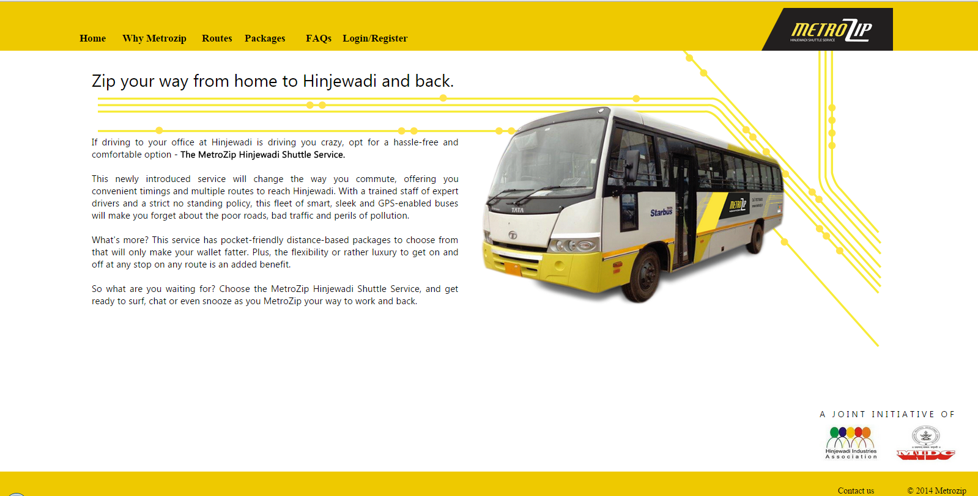

Why MetroZip
The Why MetroZip page shall be created as like showed below screen shot. The contents will be shared by SMM during the development of this application.
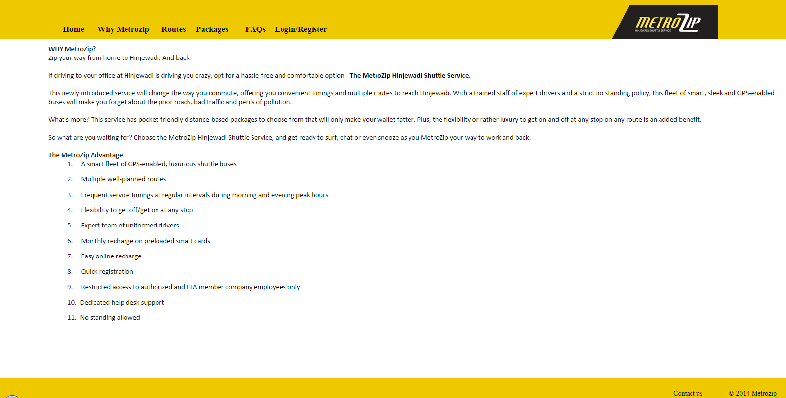

Routes
The routes page shall be picked the values from various master tables and display the information as like showed below screen shot.
Display the pickup points and times:
System should display the pickup points, route type, and pickup time details on tabular format based preferred route & route pickup time selected by users. Refer the below screen shot.
Filters: Data Source information
SL No | Field Name | Field Type | Data Source | Remarks
1 | Route Name | Dropdown | Route master
2 | Pickup start time | Dropdown | Pickup route start time master

Data Display: Source Information
SL No | Field Name | Field Type | Data Source | Remarks
1 | Pickup / Drop point | Display values | Pickup point time master
2 | Route Type | Display values | Location master.
3 | Pickup point time | Display values | Pickup point time master
Sample screen shot: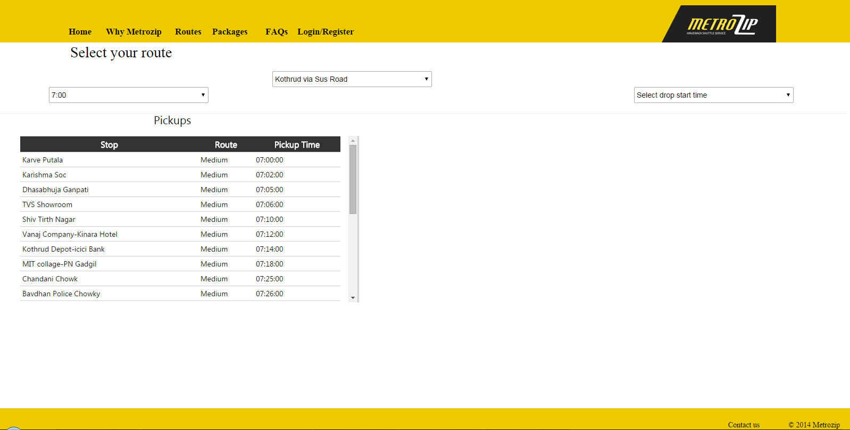
Display the Drop points and times:
System should display the drop points, route type, and pickup time details on tabular format based preferred route & route drop time selected by users. Refer the below screen shot.
Filters: Data Source information
SL No | Field Name | Field Type | Data Source | Remarks
1 | Route Name | Dropdown | Route master
2 | Drop start time | Dropdown | Drop point time master

Data Display: Source Information
SL No | Field Name | Field Type | Data Source | Remarks
1 | Pickup / Drop point | Display values | drop point time master
2 | Route Type | Display values | Location master.
3 | Drop time | Display values | drop point time master
Sample screen shot:

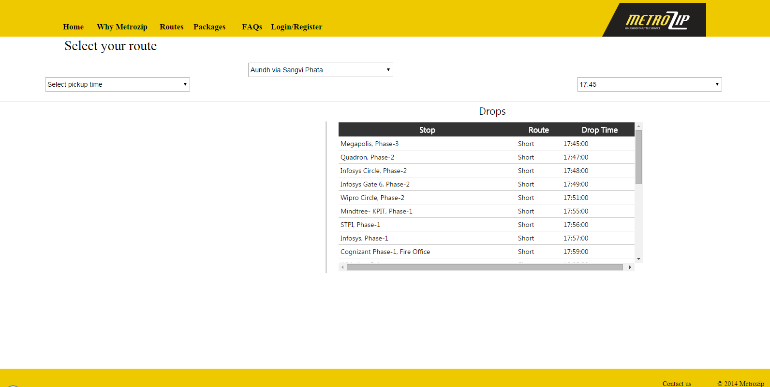

Packages
The packages page shall be picked the values from various master tables and display the information as like showed below screen shot.
Display the pricing details:
System should display the registration group type, route type and Discount % in tabular format. Refer the below screen shot.
Data Display: Source Information
SL No | Field Name | Field Type | Data Source | Remarks
1 | Registration group | Display values | Discount Master
2 | Route type | Table column Heading | Discount master
3 | Discount in % | Display values | Discount Master
4 | Amount | Calculation | Rate Master | Amount needs to be calculated based registration group, route type & Discount %
Sample screen shot:

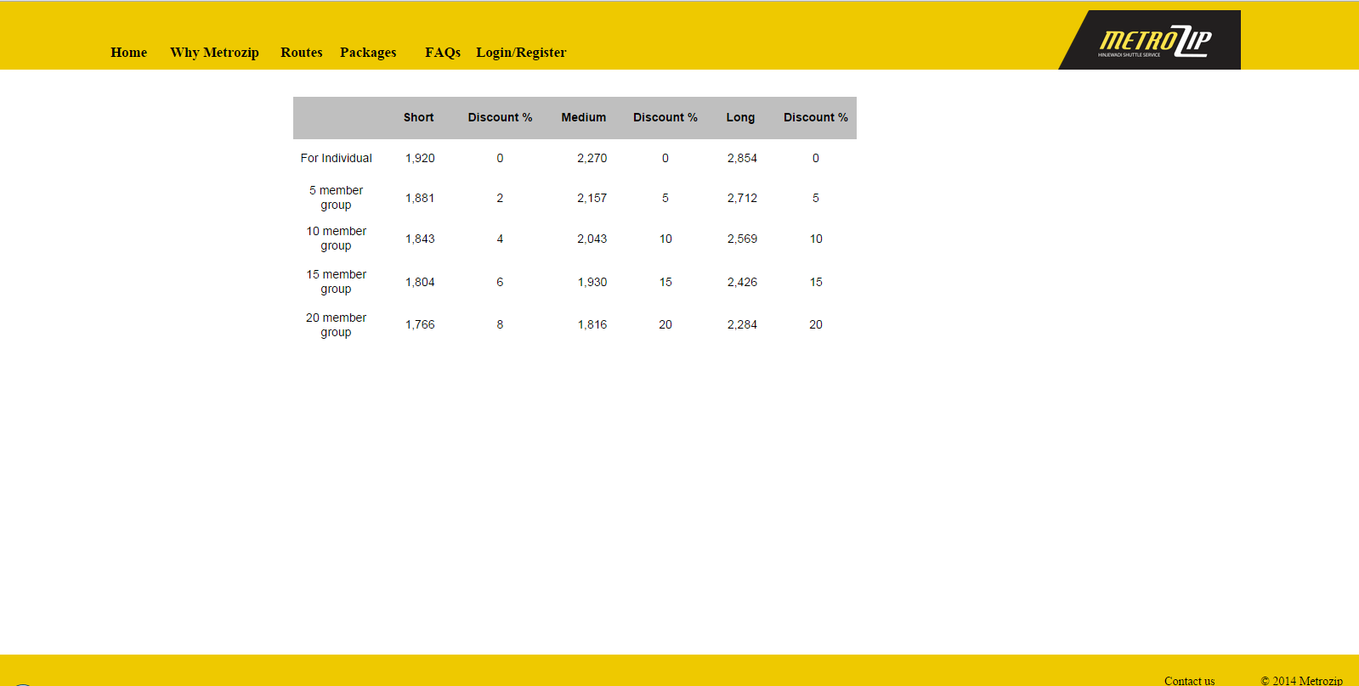

FAQs
The FAQs page shall be created as like showed below screen shot. The contents will be provided by SMM during the development of this application.

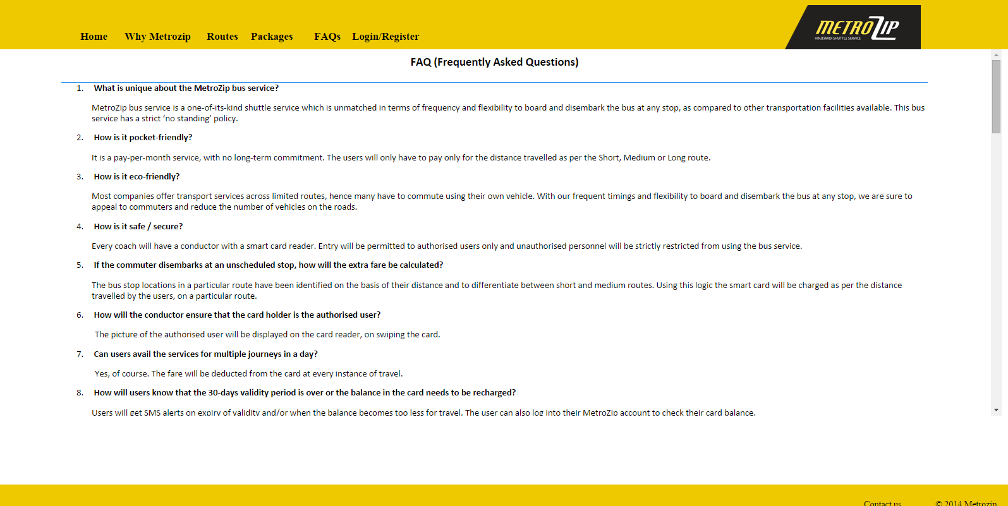

Press / Gallery
System shall display the press notes, photos & related videos on this page. Users can all photos and videos in the galley and they should be able to select particular photo and view in bigger size.

Login / Register
Login page will display the information as like below screen shot. Sign-up now button will enable user to view the registration page and capture their information.
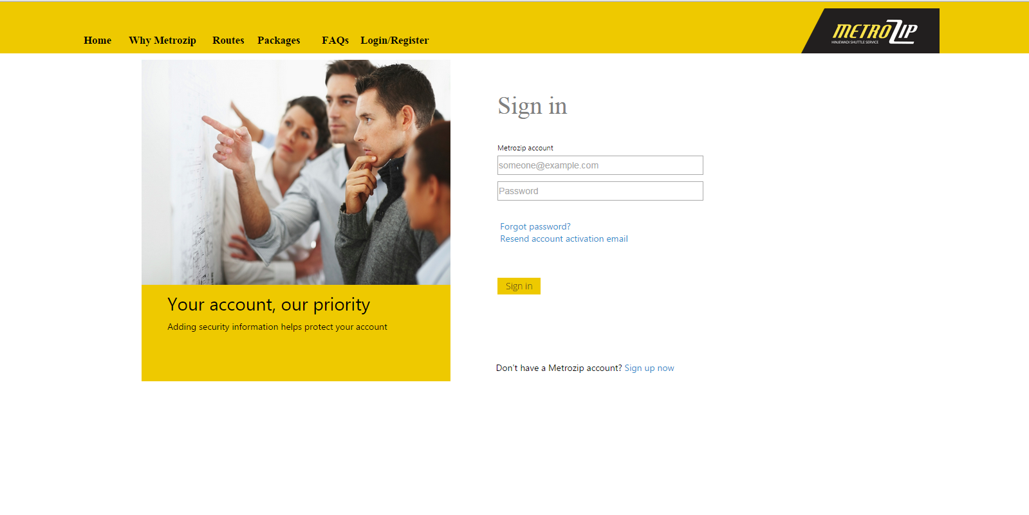

Sign-up Now
The user needs to enter their details and register for the service. The below information will be captured in the registration page.
SL No | Field Name | Field Type | Mandatory | Data Source | Data Logic / Validation
1 | Company Name | Dropdown | Y | Company master
2 | Email Id | Varchar | Y |  | System should validate for the domain name with the company master. If domain is not matched in our table, the error message should display as invalid email address.  System should check if the same email id already registered or not. If already registered, it should display the message as this email id already exists.
3 | Create Password | Varchar | Y |  | Minimum 8 characters.
4 | Confirm password | Varchar | Y |  | Create password and confirm password must matched
5 | Employee Name | Varchar | Y |  | It is a mandatory field. The system should not allow users to save the data without entering the mandatory fields.
6 | Phone Number | Numeric | Y |  | Only numeric should be allowed on this field and it should not allow more than 10 digits or less than 10 digits.
7 | Address | Varchar
8 | Employee ID | Varchar | Y |  | It is a mandatory field. The system should not allow users to save the data without entering the mandatory fields.
9 | Gender | Dropdown | Y | Male / Female
10 | Preferred Route | Dropdown | Y | Route master | It is a mandatory field. The system should not allow users to save the data without entering the mandatory fields.
11 | Pickup point from Pune City | Dropdown | Y | Location master | The values should be displayed based on the preferred route selected by user.
12 | Route Start time | Dropdown | Y | Pickup route start time master | It is a mandatory field. The system should not allow users to save the data without entering the mandatory fields.
13 | Drop Point in Hinjewadi | Dropdown | Y | Location master. | Display the values from Location master if the pickup / drop location is ticked as INDUSTRIAL ASSOCIATION stop
14 | Route start time from Hinjewadi | Dropdown | Y | Drop route start time master
15 | Upload Photo | Browse file | Y |  | Image size should not more than 100kb. The validation should be there to inform users accordingly.
16 | Check Seat availability | Calculation field |  | Check the no of users are registered in for that particular route & time. Based on the above filter, the information should display here. | The system should calculate for 90% of seat capacity from the vehicle master.
17 | Do you want to refer your friend to avail the group registration discount? | Button |  |  | If user click on this button, the pop up should open it should ask the user to enter his friend / colleague email ids.  List box should be available in the group registration form and it should not allow user to enter the same email ids again.  There should be an option to remove the email id from the list box.  Add button should validate and not allow the users to add the email ids if that email id is not valid or already registered.  Add button should not allow the same email id which has been entered in the registration form.  Close button needs to be there to close the group registration form.
18 | Service effective Date | Date |  |  | System should display only 4 dates in dropdown.  Ex: if current date is 01-09-14, the system should display the below 4 dates in the dropdown,  - 04-09-14  - 05-09-14  - 06-09-14  - 07-09-14  Basically, the service provider will be taken 3 days to deliver the NFC / RFID card to user. That’s why the start date is 4th day from the registered date. The buffer date will be limited to up to 7 days from registered date.
19 | View Agreement | Display |  |  | Display the agreement
20 | Register Button | Save Button |  |  | This button needs to save the records if all information met the validation requirements.  Email notification should send it to the user on the registration successful and account activation link.  SMM Will provide the email notification template.  System should check the seats availability and display in the new page as registration successful but seats are not available and you are in queue.  System should send email notification to all email id which have been entered in the group registration list box. Email notification template will be shared with service provider.  Registration successful message in the new page and clicking on ok button to redirect login page.
21 | Cancel Button | Button |  |  | This button should allow users to go back to login page
22 | Clear | Button |  |  | This button should allow user to clear all fields.

Seat Reservation process
Seats needs to be allocated to the paid employees based on the below seat reservation process.

Forget Password
Clicking on forget password, the new page should open and request user to enter their email id. If email id is valid and registered in our portal, the system should send them a new password and force them change their password on the first logon.

Resend account activation link
If user lost or misplaced the account activation link, they can click on resend account activation link button. Based on the click, system will display the new form and request the user to enter their email id. In this page submit button should be there. This button will validate the email id and send them the activation link again.

Sign-In
SL No | Field Name | Field Type | Mandatory | Data Source | Data Logic / Validation
1 | User name | Text box | Y
2 | Password | Textbox | Y
3 | Sign in | Button | Y |  | This button should check the database and allow user inside if their login credentials are passed. Otherwise display the error message.  After successful login, system should display the user dashboard page.

User Dashboard

Payment / Recharge
After successful login the system will be redirected to payment / recharge page. Users should be able to see below mentioned information and able to make payment or recharge for next month service.
- Monthly amount
- Monthly trip count
- Per trip cost
- Current balance trip
- Current balance amount
- Rechargeable Amount
- Pay Now button – this button should redirected to ICICI payment gateway and should have capability to capture the below information from the payment gateway.
  - Transaction status (Successful or rejected)
  - Transaction ID
  - If possible, capture the users first name
  - Transaction date
  - Amount
- After the successful transaction, the system should send the email notification to user on transaction ID, receipt No (which our application should create for all transaction), Date and amount.
- Pay now button should be enabled if the current balance trip is less than 4.
- The validity of the amount would be either 44 trips per month or 30 days.
- Current balance amount and trip should be available in pie chart as well.

My Profile
In this page, the system should display mentioned below information,
- User Name (No edit option)
- Address ( edit option)
- Email Id
- Contact Number (edit option)
- Change password (
- Image ( Edit option)

Trip Information
In this page, the system should display mentioned below information,
- Preferred Route
- Route start time
- Pickup point
- Drop point
- Change request for route or pickup point. – the system will be send the notification to helpdesk and helpdesk will have authorize to change the route and pickup point based on seat availability.

NFC / RFID Card replacement request
The system should allow users to request a new card in case they lost it. There should be an option to make the payment for this card replacement. The cost is INR 100. This information should be displayed in the admin dashboard as well. The below information should be captured in this form.
SL No | Field Name | Field Type | Mandatory | Data Source | Data Logic / Validation
1 | Reason for request of card | Varchar | Y
2 | Date | Date | Y

Transaction Report
User will be able to see their previous or old transactions details in the web. The same information can be exported into excel or word or PDF. Please find attached below report format.
Filters:
SL No | Field Name | Field Type | Mandatory | Data Source
1 | From Date | Date | Y | Payment / Recharge table
2 | To Date | Date | Y | Payment / Recharge table
Report Fields:
SL No | Field Name | Data Source | Remarks
1 | Date | Payment / Recharge table
2 | Transaction Id | Payment / Recharge table
3 | Transaction Status | Payment / Recharge table
4 | Paid Amount | Payment / Recharge table
5 | Receipt No | Payment / Recharge table

Trip Usage Report
User will be able to see their otrip usage details in the web. The same information can be exported into excel or word or PDF. Please find attached below report format.
Filters:
SL No | Field Name | Field Type | Mandatory | Data Source
1 | From Date | Date | Y | User attendance table
2 | To Date | Date | Y | User attendance table
3 | Employee Name / Email id | Dropdown |  | Registration table. This field may not be selected by user. The system should display the name based on the login.
Report Fields:
SL No | Field Name | Data Source | Remarks
1 | Swiping Date | User attendance table
2 | Swiping Location | User attendance table
3 | Swiping time | User attendance table
4 | Employee name | User attendance table

Referral Information Report

The follow details needs to be displayed in the user dashboard based on date range,
  - No of referrals,
  - No of referrals success
  - Discount / benefit.
Also available for user to view all of his / her referral email ids in the web and can be export into excel or word or PDF.

Admin Dashboard

NFC / RFID Card Issue Form
Admin team will be accessing this form to issue the card and enter the below details.
SL No | Field Name | Field Type | Mandatory | Data Source | Data Logic / Validation
1 | Card Number | VarChar | Y
2 | Employee Name | Dropdown | Y | Registration table | Dropdown with search box option required.
3 | Issue date | Date | Y
4 | Card Type | Dropdown | Y | New / Replacement
5 | Issued by | Dropdown | Y | Courier / in person
6 | Handed over by | Varchar | Y |  | This field not required if previous field is slected as courier.

Vehicle Deployment

SL No | Field Name | Field Type | Mandatory | Data Source
1 | Vehicle No | Dropdown | Y | Vehicle master
2 | Driver Name | Display field |  | Based on vehicle no, the driver name should be displayed.
3 | Route name | Dropdown | Y | Route master
4 | GPS device No. | Varchar | Y
6 | GPS status | Dropdown | Active / In active

Route / Time change request activation
Helpdesk team should view this form and action the request from users
SL No | Field Name | Field Type | Mandatory | Data Source
1 | Employee Name | Display |  | Change request form
2 | Email id | Display |  | Change request form
3 | Change request date | Display |  | Change request form
4 | Change request status | Dropdown | In-Progress / Closed / Pending
5 | Change request action date | Date

Vehicle Tracking
Admin team will be able to track the vehicle real time. The map should be displayed with the bus location and seats availability on real time.
Real time tracking:
Admin can select the route name & Vehicle no to see the bus’s real time travel location in map and display the below information aside as well,
- Bus start time
- Start place
- Current place
- Distance covered so far
- Time taken from first point
- Approximate reaching time for last point
- How many users boarded the bus.

View Vehicle’s past travel history:
Admin can select the route name, Vehicle no, date to see the bus’s traveled details in map and display the below information aside as well,
- Display the map with travelled path with all locations
- Display the no of users boarded on bus for each locations
- Bus start time
- Start place
- Current place
- Distance covered so far
- Time taken from first point to last point
- Last point reached time

Seat occupancy monitoring
Admin team should be able to track the seat occupancy for all buses on real time basis.

Pickup time monitoring
Admin team should be able to track the pickup time of all stops for all buses on real time basis.

Drop Time Monitoring
Admin team should be able to track the drop time of all stops for all buses on real time basis.

.

NFC / RFID card swiping Monitoring
Admin team should be able to track the NFC / RFID card swiping of all users for all buses on real time basis.

Travel time for Pickup – Weekly Comparison Report
Filters:
- Route Name
- Vehicle No
- From Date (Monday)
- To Date (Friday)
- Route Pickup start time
Data Display:
 | 01-01-2001 | 02-01-2001 | 03-01-2001 | 04-01-2001 | 05-01-2001
Pickup Point Name | Monday | Tuesday | Wednesday | Thursday | Friday
PP-1 | 07:00 | 07:02 | 07:00 | 07:09 | 07:00
PP-2 | 07:04 | 07:06 | 07:04 | 07:13 | 07:03
PP-3 | 07:09 | 07:11 | 07:08 | 07:17 | 07:07
PP-4 | 07:14 | 07:16 | 07:14 | 07:22 | 07:13
PP-5 | 07:29 | 07:37 | 07:25 | 07:35 | 07:26
PP-6 | 07:37 | 07:43 | 07:37 | 07:41 | 07:32
PP-7 | 07:52 | 07:59 | 07:50 | 07:56 | 07:47
PP-8 | 08:02 | 08:09 | 08:00 | 08:06 | 07:57
Graphical Display:
Filters:
- Route Name
- Vehicle No
- From Date (Monday)
- To Date (Friday)
- Route pickup start time
- Pickup Point name

Travel Time for Drop – Weekly Comparison Report
Filters:
- Route Name
- Vehicle No
- From Date (Monday)
- To Date (Friday)
- Route Drop start time
Data Display:
 | 01-01-2001 | 02-01-2001 | 03-01-2001 | 04-01-2001 | 05-01-2001
Pickup Point Name | Monday | Tuesday | Wednesday | Thursday | Friday
DP-1 | 07:00 | 07:02 | 07:00 | 07:09 | 07:00
DP-2 | 07:04 | 07:06 | 07:04 | 07:13 | 07:03
DP-3 | 07:09 | 07:11 | 07:08 | 07:17 | 07:07
DP-4 | 07:14 | 07:16 | 07:14 | 07:22 | 07:13
DP-5 | 07:29 | 07:37 | 07:25 | 07:35 | 07:26
DP-6 | 07:37 | 07:43 | 07:37 | 07:41 | 07:32
DP-7 | 07:52 | 07:59 | 07:50 | 07:56 | 07:47
DP-8 | 08:02 | 08:09 | 08:00 | 08:06 | 07:57
Graphical Display:
Filters:
- Route Name
- Vehicle No
- From Date (Monday)
- To Date (Friday)
- Route Drop start time
- Drop Point name

Mobile Device Battery Tracking
Admin team should be able to track the mobile device battery level in percentage for all buses on real time basis.

Occupancy Report
The mentioned below fields should be available on this report,
Filters:
- From Date
- To Date
- Route start time
Report fields Display:
- Date
- Vehicle No.
- Route
- Pickup –up point / Drop point
- Pickup point
- Pickup Occupancy
- Drop time
- Drop Occupancy

Number of Trips Report
The mentioned below fields should be available on this report,
Filters:
- From Date
- To Date
Report fields Display:
- Date
- Vehicle No.
- Route Name
- Route Pickup start time
- No of trips
- Route Drop Start time
- No of trips

Most Used Points Report
The mentioned below fields should be available on this report,
Filters:
- From Date
- To Date
- Route start time
Report fields Display:
- Date
- Route
- Most used Pickup Point
- Number of occupancy
- Most used Drop point
- Number of occupancy

Employee wise payment Report
The mentioned below fields should be available on this report,
Filters:
- From Date
- To Date
Report fields Display:
- Employee Id
- Employee Name
- Email Id
- Contact Number
- Route name
- Route pickup Start time
- Pickup point from Pune City
- Route Drop start time
- Drop point from Hinjewadi
- Date of Registration
- Registration type
- Paid Amount
- Date of Payment

Multiple trips by Employee in a Day
The mentioned below fields should be available on this report,
Filters:
- Date
Report fields Display:
- Date
- Name of Employee
- Route name
- Vehicle No
- Pickup Point
- No of times travelled
- Drop point
- No of times travelled

Unscheduled Location Travel Report
The mentioned below fields should be available on this report,
Filters:
- From Date
- To Date
Report fields Display:
- Date
- Route Name
- Vehicle No
- Name of Employee
- Schedule Pickup point
- Schedule Drop Point
- Unscheduled Pickup Point
- Unscheduled Drop point
- Cost Impact on trip (+/-)

Unscheduled Shift Travel Report
The mentioned below fields should be available on this report,
Filters:
- From Date
- To Date
Report fields Display:
- Date
- Route Name
- Vehicle No
- Name of Employee
- Schedule Pickup point
- Schedule Drop Point
- Unscheduled Pickup Shift
- Unscheduled Drop Shift

Registration Report
The mentioned below fields should be available on this report,
Filters:
- From Date
- To Date
Report fields Display:
- Employee Id
- Employee Name
- Company Name
- Email Id
- Contact Number
- Route name
- Route pickup Start time
- Pickup point from Pune City
- Route Drop start time
- Drop point from Hinjewadi
- Date of Registration
- Registration type

Financial Report
The mentioned below fields should be available on this report,
Filters:
- From Date
- To Date
Report fields Display:
- Transaction Date
- Transaction Id
- Employee Id
- Employee Name
- Company Name
- Email Id
- Contact Number
- Route name
- Route pickup Start time
- Pickup point from Pune City
- Route Drop start time
- Drop point from Hinjewadi
- Date of Registration
- Registration type
- Paid Amount
- Date of Payment
- Payment Mode
- Discount

Real time Card Swiping Report
The mentioned below fields should be available on this report,
Filters:
- From Date
- To Date
Report fields Display:
- Employee Id
- Employee Name
- Email Id
- Company Name
- Swiping time - pickup
- Swiping Location - pickup
- Swiping time – drop
- Swiping location – drop
- Card balance Amount
- Card balance Trips
- Route Type

Email Notification Templates
Email notification templates needs to be updated by admin team and setting up the dates of alerts and type of alerts.
Service provider should provide us a form to setup the email notification and below information should be captured to activate the alerts
- Registration successful & account activation notification
- Notification to users whose name been referred in group registration scheme.
- Payment transaction successful notification
- Reminder emails to registered users to request them make payment –Admin should have option to set the date(s) to trigger the mails.
- Email notification to all registered users on referral program.

Referral Program
One page requires for admin selecting the referral program date & validity of the referral. The system should send all registered users an email with referral page link on referral program details.
User needs to be entered the email ids of his / her friends or collogues and click submit button.
System should validate the email id as mentioned below when the user click on the submit button.
- System should not accept if the email id already registered with MetroZip.
- System should not allow users to enter the same id for multiple time
- System should not allow the users to enter the email id which has been referred by some other user.
- System should not allow the email id which is not valid.
- System should calculate and provide the discount to referrer, based on how many users (which he /she have referred) have been registered and paid. The calculation table (trips / cost & no of days extra) will be provided by SMM team.

Promotion Offer Program
One page requires for admin to selecting the promotional program date, offer option & link validity of the promo. The system should generate the coupon and promo link. The link & Coupon will be share with all INDUSTRIAL ASSOCIATION member company’s employees. The link should be de-activated based on promo’s expiry date mentioned in the promo page.
System should calculate the card balance and trips based on the promotion offer master and offer option mentioned in promo page.

Mobile App Requirements
Mobile app needs to be developed for android, IOS and windows platform. User should be able to access the app on all sizes of mobile & tablets.

Login / Registration Screen
Login & Registration screens needs to be designed as like web for mobile app. After successful logon, the app should redirect to Home page.

Home page
User will be able to see the icons based on his access level.
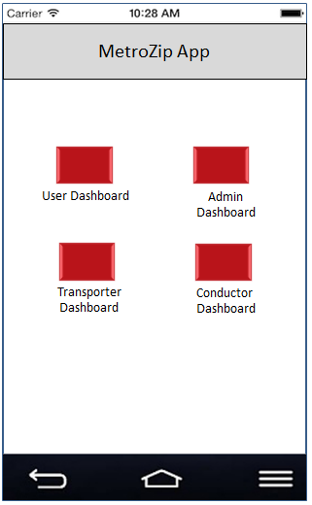

User Dashboard
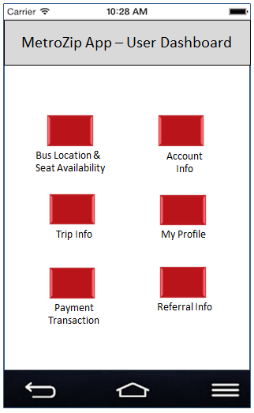

Bus Location & Seats Availability
App should display the default values for route name and route start time as per user registered the information.
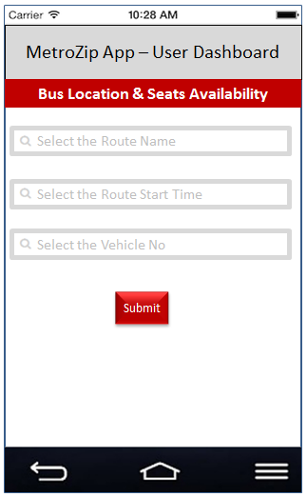
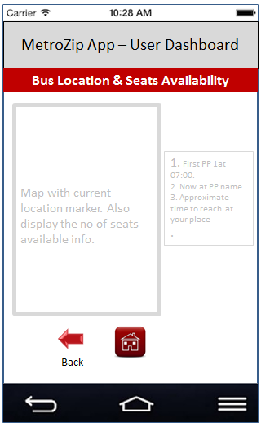

Account Information
In this screen app should display payment information. The user will have to use the web application for make the payment.
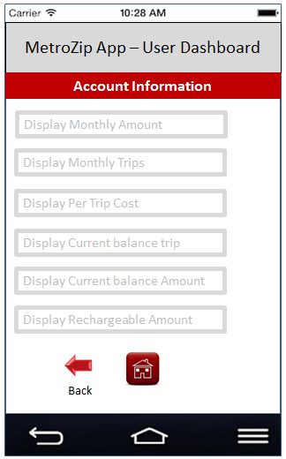

Trip Information
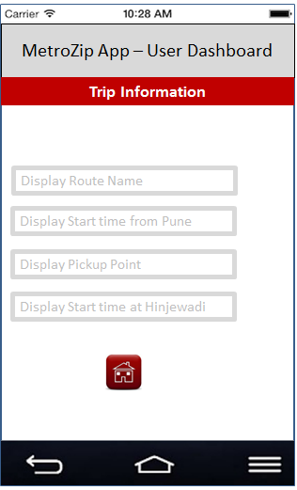

My Profile
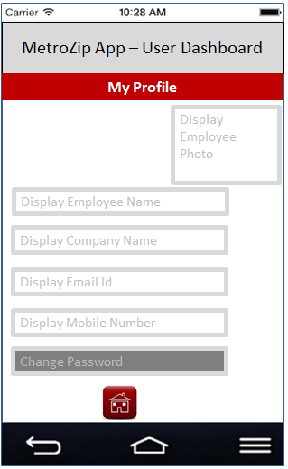

Payment Transaction
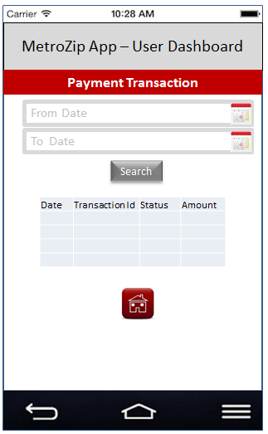

Travel usage Information
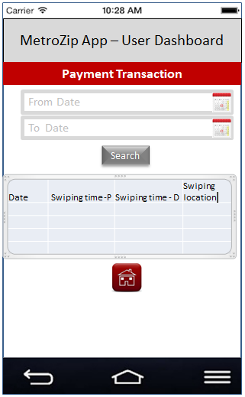

Transporter Dashboard

Bus Information
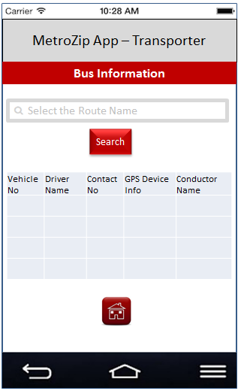

Vehicle Tracking

Mobile Device Battery Info

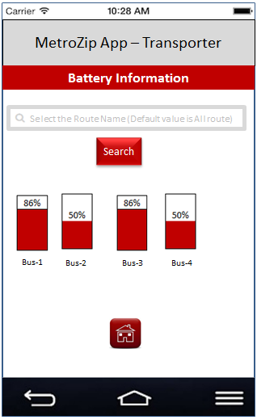

Conductor Dashboard

Card Swiping (Attendance)
Conductor will swipe all boarded employees NFR card and the app will be capture the location name based on latitude longitude from the device. Based on swiping & the location, system should calculate the employee’s card balance amount and trip.
